KEYSTONER
Keystone Capital Chapter
“Never Stop Serving”

November 2021

PA House Bills Reconfigure Veteran Programs - Administration

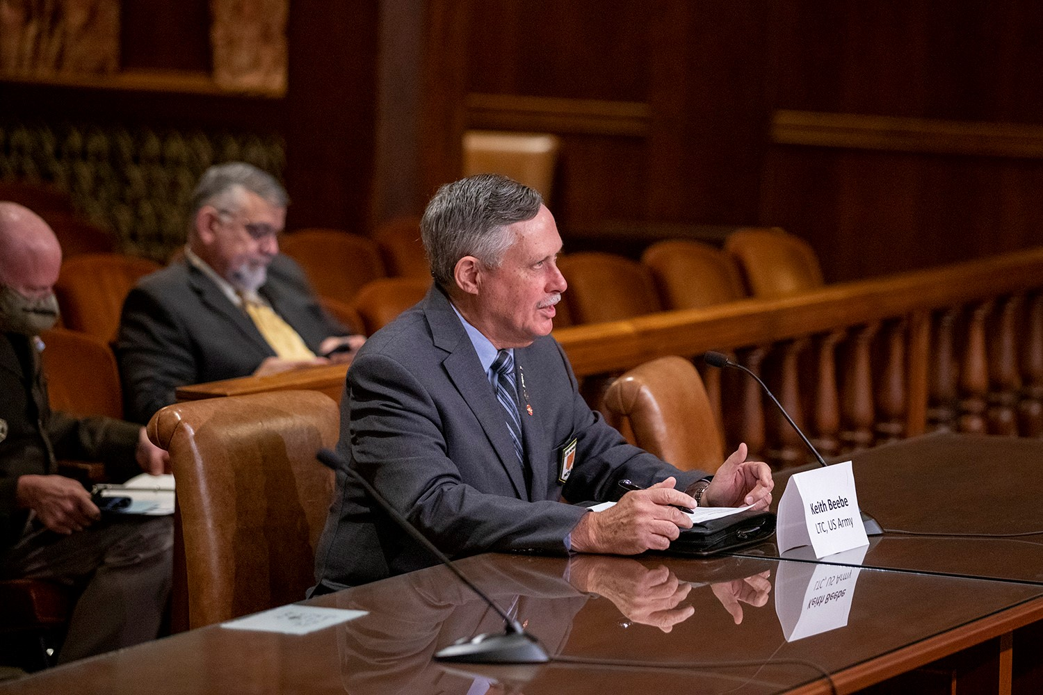
LTC Keith G. Beebe, USA Ret. MOAA PA Council of Chapters President, testifies before the House Veterans Affairs Committee as a member of the State Veterans Commission Disabled Veteran Real Estate Tax Exemption Committee.

The Pennsylvania House Veterans Affaris and Emergency Preparedness Committee held a information hearing on October 19, 2021 to discuss several new bills introduced to increase funding for veteran programs, reconfigure or improve the administration of veteran programs.
Some of the bills proposed include Veteran’s Lottery Ticket, reconfiguring the
Inside:
Pg. 4 New Bills
& Medical Billet
Cuts
Pg. 6 Tricare for
Life
Pg.9 Veteran
Discounts
Pg.10 Dinner
Invite

legislslation TRICARE
For Life

Pg. 10 Dinner

State / Federal
Legislation

Page 8-9
News stories

Page 10
Dinner Invite
State Veterans Commission, changes to the state constitution regarding Disabled
Veterans Real Estate Tax Exemption, creating a State Veterans Home Advisory
Board, and creation of an independent agency for veterans’ affairs. The state Senate
has Senate introduced a bill to reduce registration for vehicles registered to a
veteran to only a $11.00 administrative fee. None of the bills have been discussed
further by the committees to determine if they will be voted out for further review
by other committees on the way to being voted on by the full legislature.
September Dinner Meeting at the Radisson
Dr. Evan Ellis, a research professor of Latin American Studies at the U.S. Army War College
Strategic Studies Institute, presented an interesting view of the region’s relationships with China and other
non-Western Hemisphere actors, as well as transnational organized crime and populism in the
region. Thanks to chapter member Joe Gottwald for contacting Dr. Ellis as they became acquainted while attending the National Defense University. Thank you for coming out to speak with us in person.

Chapter Board Meetings and Return to in Person Meetings

The Keystone Capital Chapter Board of Officers have begun meeting in person. Board meetings are held the second Tuesday at 11:30 am in the rear meeting room at Denny’s restaurant on the Carlisle Pike. Any members are welcome to join us. At the last Board meeting the annual donation to Wreaths Across America was approved and a donation of $135.00 was approved for the Fort Indiantown Gap Wreaths Across America that will provide nine wreaths for the graves. The annual wreath laying is December 18, 2021.

Our dinner meetings are being held at the Penn Harris Hotel, formerly the Radisson. The property was purchased by the Triple Crown Corporation and is being managed by the Centre Hotel Corporation in State College, PA. Our meeting room location has changed. Our meeting room is now located in the upper Convention Center, near the Perkins Restaurant. There is parking to the left of the building and some just past the front door. Both lots are level and not far from the door. Our meeting room is in the front door and turn left to the first room on the left, Keystone A. It is the room with a bar and bar tender in it. The chapter received excellent service for our September dinner.

Tuesday night November 16th at 6 PM is the next chapter dinner meeting. The Social hour starts at 5 PM so come early to talk with others before the meeting. This meeting will feature information learned at the MOAA Annual Meeting and from our guest speaker the Secretary of Veterans Affairs Denis McDonough.

The slate of proposed officers for the 2022 term are Chapter President Bob Gray, First Vice President Keith Beebe and Secretary/Treasurer Fred Lovelace. The office of Second Vice President is open for nominations from the floor during the meeting.

Additional information

For information or if you need help for the Survivor Benefits Program (SBP) please call 1-800-321-1080.

If anyone knows of an ill or recuperating chapter member, please contact Jan Beebe at 717-761-5335. She will send a card from the Chapter.

To join the Keystone Chapter, contact our Membership Chairman Keith Beebe at 717-761-5335.

The Military Officers Association of America (MOAA) is a nonpartisan military nonprofit organization that does not engage in partisan politics and works with all political leaders in moving military and veterans’ legislation that will help the men and women who currently serve, the retired, their families and their survivors. The views presented in the Keystoner newsletter are those of the editor and do not represent the opinions of the Keystone Capital Chapter officers, PA Council members or represent the views of MOAA’s national officers, staff or Board of Directors. Bob Gray, Editor.

5 Star Levels of Excellence Awards to 135 Councils and Chapters

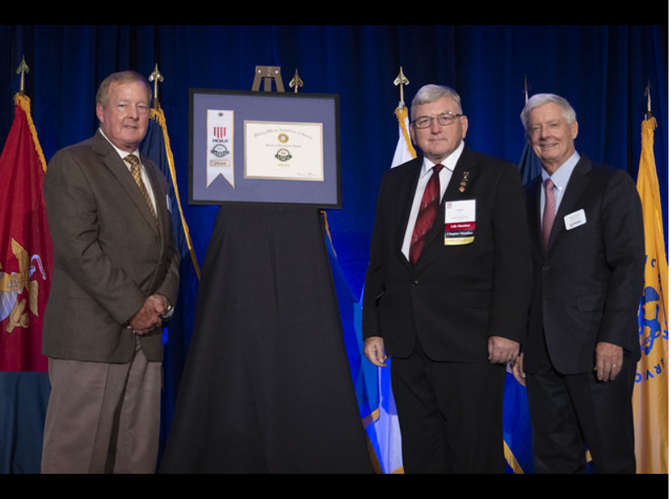
LT Gen Dana Atkins USAF Ret., President and CEO of MOAA and Gen Walter Skip Sharp USA Ret., Chairman of the MOAA Board of Directors, present the 5 Star Levels of Excellence Award to Bob Gray from Keystone Capital Chapter

The 5 Star Levels of Excellence award was won by the PA Council of Chapters, Lancaster Chapter, Pittsburgh Chapter and Keystone Capital Chapter. Thank you to all Keystone Capital chapter members for supporting your chapter to make this award possible.

State Legislation

Bob Gray – Legislative Chairman
Legislative Information from the General Assembly web site: http://www.legis.state.pa.us

Click on the blue link beside each bill to go to the full description of the legislation.

Veterans Issues Active in the State Legislature as of November 2, 2021

HB1691 Veterans Lottery Ticket
(K. Boback) Funding would be placed in the Veterans Trust Fund to fund veterans’ programs.

HB1964 (K. Boback) Create Independent agency for Veterans Affairs and criteria for selection of Deputy Adjutant General.

HB1978 (M. Pennycuick) Reorganize/reform of the State Veterans Commission.

HB1963 (F. Ryan) Creation of a Veterans Home Advisory Board. To oversee state veterans’ homes and selection of Deputy Adjutant General and Director of homes.

SB 504 (P. Stefano) License Plate Fee Reduction for veteran’s vehicle registration.

SB276 (J. Ward) Blind and Amputee & Paralyzed Veterans Pension Increase – from $150 to $180 a month. Passed Senate June 8, 2020. In the House June 9,2020.
No movement

SB957(Bartolotta) Veterans Business Logo Passed Senate June 22, 2020. In House June 23,2020. No Movement

Disabled Veterans Real Estate Tax Exemption Bills:

HB 1953 (C. Sainato) Changes the PA Constitution regarding Disabled Veterans Real Estate Tax Exemption. This legislation will add eligibility for the Spouse of a soldier Killed in Action or who died from wounds while on active duty. It will also removal the War time clause which limits eligibility by dates of service not disability.

Federal Legislation

Ask Your Lawmaker to Delay DoD’s Planned Medical Billet

Cuts
By Karen Ruedisueli, MOAA Staff

As the FY 2022 National Defense Authorization Act (NDAA) moves toward conference, where the House and Senate will reconcile differences between their versions of the bill, MOAA remains focused on supporting a key provision to ensure continued beneficiary access to quality health care.

Section 721 of the House bill – which has already passed its chamber – would halt DoD’s plan to cut medical billets for a year following the enactment of the FY 2022 NDAA. It also would require a Government Accountability Office (GAO) report on the analyses used to support billet cut plans, including an evaluation of medical manpower requirements and the effect of billet cuts on local health care networks.

Section 721 of the House bill – which has already passed its chamber – would halt DoD’s plan to cut medical billets for a year following the enactment of the FY 2022 NDAA. It also would require a Government Accountability Office (GAO) report on the analyses used to support billet cut plans, including an evaluation of medical manpower requirements and the.

[TAKE ACTION: Urge Your Lawmakers to Stop Cuts to Military Medicine]
The Senate NDAA, while still subject to floor amendments and debate, does not include this language at
present. Keeping the House section in the final bill will be critical to pr
eventing planned cuts from corroding your earned health care benefit.

A recently released DoD report to Congress gave us the first glimpse at how medical billet cuts might impact individual military treatment facilities (MTFs) but offers few details on specific positions to be cut or mitigation plans for impacted beneficiaries. It also raises the following concerns:
- Most eliminated billets will be replaced either with civilian hires or contract personnel, or absorbed by remaining MTF staff. However, the report does not indicate what, if any, analysis has been done to assess the feasibility of hiring civilian replacement personnel or the ability of current staff to absorb additional workload.
- Medical billet cuts have been reduced from 17,005 in the original proposal to 12,801 – a move driven primarily by the Army, which accounted for 95% of the adjustment. The medical billet cuts proposed by the Navy and Air Force appear to remain almost unchanged, and MOAA remains concerned lessons learned regarding Military Health System surge capacity requirements and limits to civilian provider availability have not been fully considered in the Navy and Air Force plans.

[RELATED: A Major Pharmacy Provider Is Rejoining the TRICARE Network. Another Is Leaving]

- Although many of the cuts are for administrative or other nonclinical positions, there are still a substantial number of medical provider billets proposed for elimination, including 779 physicians and 1,081 nurses.
MOAA also is concerned about significant cuts planned for pediatrics and mental health billets – areas already are under strain in the civilian health care system. While MOAA supports military health system reforms aimed at enhancing the focus on medical provider readiness, the recent report to Congress indicates DoD has not conducted the analysis and feasibility assessments necessary to ensure continued access to quality care for beneficiaries.
Please amplify our efforts by contacting your lawmakers and urging them to support
Section 721 of the House NDAA as the FY 2022 NDAA process continues.
[RELATED: Here Are Your New TRICARE Pharmacy Drug Prices]

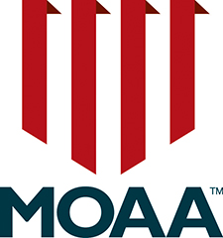

The Benefit Under Threat: Saving TRICARE For Life
By: Karen Ruedisueli
NOVEMBER 01, 2021
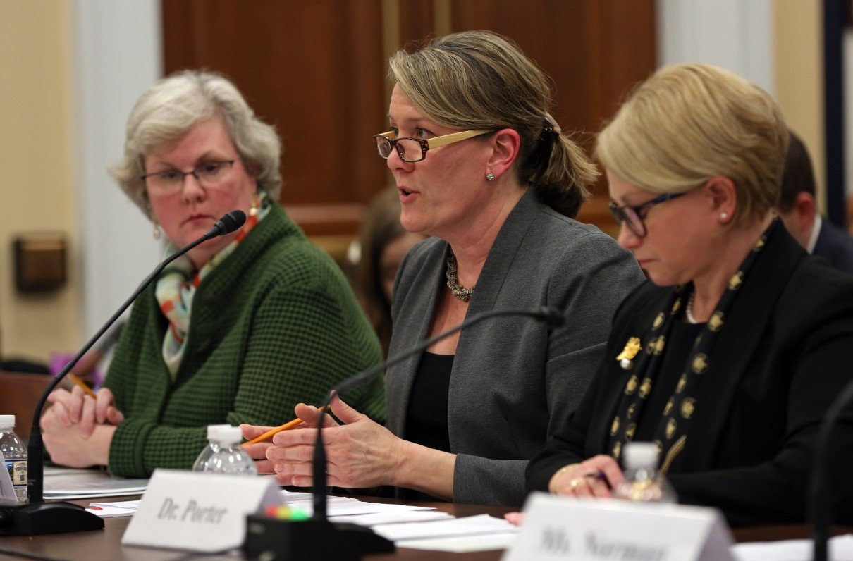Karen Ruedisueli, MOAA's director of government relations for health affairs, testifies before the House Armed Services Subcommittee on Military Personnel during a Feb. 5, 2020, hearing. (Photo by Jennifer Milbrett/for MOAA)

October 2021 marked the 20th anniversary of TRICARE For Life (TFL), one of the largest expansions of the military health care benefit and a huge win for MOAA and other military advocates who worked tirelessly to secure a robust health care benefit for Medicare-eligible military retirees.

While the 20th anniversary provides an opportunity to reflect on the TFL victory and the advocacy efforts that drove it, we are also reminded of the importance of protecting the benefit for current Medicare-eligible retirees as well as future generations of TFL enrollees, all of whom sacrificed greatly in support of our nation.

TFL has been under threat for years — both for those who currently rely on the benefit and for our newest generation of military retirees, even after years of war have highlighted the risks and sacrifices associated with career military service. Here is a look at how TFL came to be, why it is more important now than ever, and what lies ahead to protect it.

Meeting a Need
The uniform military health care benefit was created by the Dependents Medical Care Act of 1956, which defined access to military treatment facility (MTF) care in statute. It granted space-available access to MTF care for active duty family members, retirees and their families, and survivors. From 1956 to 2001, the only military health care benefit for retirees aged 65 and older was space-available MTF care and prescription drugs from MTF pharmacies, both at zero out-of-pocket cost.

The post-Cold War drawdown led to the downsizing or closure of many installations and military hospitals. Retirees in these areas lost MTF access and, therefore, their only military health care benefit.

Throughout the 1990s, MOAA and other advocacy groups fought for legislation to improve the health care benefit for Medicare-eligible retirees. Some
organizations and individuals turned to the courts claiming breach of contract and said DoD and the services had promised career servicemembers free health care for life. This perception was reinforced by decades of readily available free MTF care.

Federal courts have held there is no legal basis for the claim to free health care for life since it is not supported by statute and regulations and does not grant a right to MTF care, or other free medical care, for retirees and their dependents. However, an appellate court acknowledged the validity of retiree claims and urged Congress to fulfill its moral obligation to retirees.

[RELATED: This Government Report Estimates the Next 6 Years of Medicare Part B Premiums]

MOAA and the TFL Win
MOAA and other military advocacy groups achieved a long-standing goal when Congress addressed military retiree access to care by establishing TFL in the FY 2001 National Defense Authorization Act (NDAA).

TFL provides wraparound coverage that pays out-of-pocket costs after Medicare reimbursement for Medicare-covered services. TFL beneficiaries are also eligible for all TRICARE benefits not covered by Medicare, including medical care overseas. The bill also expanded the TRICARE retail and mail order pharmacy programs to Medicare-eligible retirees who had been limited to filling prescriptions at MTF pharmacies.

Media called the TFL win a “stunning turnaround” and reported TFL would increase the lifetime value of the military health care benefit by more than a third. Senior DoD officials called TFL “the Golden Supplement.”

“When Congress enacted TFL, legislators and Pentagon officials alike acknowledged the statutory omission of a cash premium for TFL was to recognize career servicemembers had pre-paid steep premiums through a career of service and sacrifice in uniform,” said Col. Steve Strobridge, USAF (Ret), MOAA’s former vice president for Government Relations. “The only requirement was to enroll in Medicare Part B, as the vast majority of Medicare-eligible retirees had been doing anyway.

“From the 1990s to 2001,” Strobridge added, “we worked hard to highlight the shameful situation that the military was the only large employer in America that provided its 65-and-older retirees no employer-paid coverage beyond Medicare. Enactment of TFL and associated pharmacy benefits transformed military retirees’ medical coverage to one of the very best.”

The TFL benefit has become even more important given the specialization and subspecialization in health care. TFL allows military retirees to access the care they need with no out-of-pocket cost for most services.

Over the past two decades, the limitations of space-available MTF care for retirees have been underscored by medical provider deployments to support overseas operations and, more recently, the response to COVID-19. TFL has ensured all military retirees have affordable access to care even when MTF capacity is constrained.

TFL Under Attack
Since its launch in 2001, TFL has come under budgetary attack in multiple legislative cycles. MOAA has been at the forefront, working with other advocacy groups and The Military Coalition to preserve the benefit for Medicare-eligible uniformed services retirees and their families. MOAA’s advocacy efforts, including congressional testimony, statements for the record, and engagement with Armed Services Committee staff and member offices on Capitol Hill, successfully blocked five consecutive administration budget request proposals for a TFL enrollment fee in fiscal years 2013-2017.

The appropriate level of out-of-pocket costs for beneficiaries has been a topic of debate since the military health care benefit was passed into law in 1956. The creation of TFL has had a significant impact on DoD health care spending. Calls for a TFL enrollment fee and other beneficiary cost increases will likely continue in the future given DoD budget constraints.

Safeguarding TFL for a New Generation
It would be unconscionable for Congress to increase costs for Medicare-eligible military retirees who currently rely on TFL, and MOAA has successfully made that argument for many years.

Most recent proposals to cut TFL have targeted our newest generation of military retirees — equally unacceptable. Blocking proposed cuts to the TFL benefit is a top priority for MOAA. It’s as true today as in 2001 when TFL was enacted that career servicemembers and their families pay far steeper premiums than any civilian for their benefits in retirement, and they pay them upfront through extended service and sacrifice.

The TFL benefit was a key component of the compensation and benefits package that sustained the all-volunteer force through two decades of war. Congress must not reduce the benefit just as the generation that served a full career amid high op tempo and repeated combat deployments reaches retirement. Our servicemembers earned
comprehensive health care coverage and MOAA will work to ensure it is there when they need it most.

What has TFL meant for your military family? Please join us in our efforts to protect TFL by sharing your stories at legis@moaa.org.

Get Your 2021 Veterans Day Discounts
NOVEMBER 02, 2021

By Contributing Editor Blair Drake

Food and Dining

Bob Evans: Veterans and active duty servicemembers receive a free meal from a special menu of seven homestyle favorites at their local restaurant Nov. 11.

Chili’s: Veterans and active duty servicemembers receive a free meal from a select menu Nov. 11 at participating Chili’s Grill and Bar restaurants.
Denny’s: Veterans and servicemembers get a free build-your-own Grand Slam Nov. 11 from 5 a.m. to noon at participating locations.

Golden Corral: Active duty servicemembers and veterans get a free dine-in meal Nov. 11 from 5 p.m. to close.

Target: Military personnel and veterans and their families get a discount of 10% off a storewide purchase – in stores or online – through Nov. 13. To receive the offer, guests must first demonstrate eligibility by registering here. After eligibility has been verified, guests can use the exclusive Target Circle offer in-store or online, available for two-time use.

Pilot, Flying J and One9 Fuel Network: Veterans authenticated with ID.me in the myRewards Plus app can save their exclusive offer for a $10 free meal credit. Veterans can choose from a variety of food and beverages, including Pilot coffee, fountain drinks, non-alcoholic cooler beverages, hot and cold food items, name-brand snacks, and purchases at over 680 participating restaurants.

Red Lobster: Veterans, active duty servicemembers, and reservists receive a free dine-in appetizer or dessert Nov. 11. Guests need to show a valid military ID or proof of service to redeem this offer.

Sheetz: Servicemembers and veterans get a free meal at all of Sheetz’s 633 locations, and a free car wash at locations with a car wash.

Starbucks: Veterans, servicemembers, and military spouses get a free tall (12-ounce) hot brewed coffee at participating U.S. stores Nov. 11.

KEYSTONE CAPITAL CHAPTER
CHAPTER MEETING
November 16, 2021
Penn Harris Hotel, Camp Hill – Keystone A in Convention Center

SOCIAL 5:00PM DINNER 6:00 PM
Grilled Salmon
(Grilled Salmon fillet with Caramelized Pineapple Sala)
Or
Chicken Palermo
(Baked Chicken Breast Topped with House made Fresh Bruschetta Loaded with Tomatoes,
Basil, Garlic and Finished with Melted Provolone Cheese)

CASH BAR IN ROOM

Dinner Invitation

Tuesday November 16th Penn Harris Hotel 6:00 PM

Report from MOAA Annual Meeting, Levels of Excellence Award, Nomination of Officers for 2022 term

Price per person: $30.00 Choose #: ____ Grilled Salmon ____ Chicken Palermo

Make check out to: Keystone Capital Chapter

Names of Members and Guests attending:

______________________________________________________

**Please Reply NLT Friday, November 12th to Host:

Keith Beebe
108 April Drive
Camp Hill, PA 17011
(Home) 717-761-5335 (Email) keith.beebe@verizon.net

